DSP Final Exam. Class:_電通三甲_, Student ID:_04050432__, Name:__戴寧__

- Compute the DFS coefficients of the following periodic sequences using (a) the DFS definition and (b) Matlab.
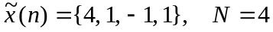.

x=[4,1,-1,1];
N=4;
Xk=dfs(x,4)
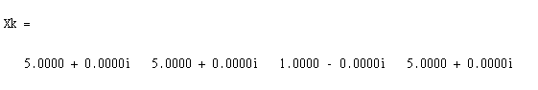

- A periodic “square wave” sequence is given by
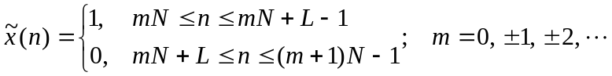
where N is the fundamental period and L/N is the duty cycle.
(a) Determine an expression for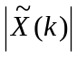 in terms of L and N.
(b) Plot the magnitudefor L=5, N=20; and L=7, N=60.
L = 5;
N = 20;
xn = [ones(1,L),zeros(1,N-L)];
Xk = dfs(xn,N);
magXk = abs([Xk(N/2+1:N) Xk(1:N/2+1)]);
k = [-N/2:N/2];
stem(k,magXk);
axis([-N/2,N/2,-0.5,5.5]);
xlabel('k');
ylabel('Xtilde(k)');
title('DFS of SQ. wave: L=5, N=20');

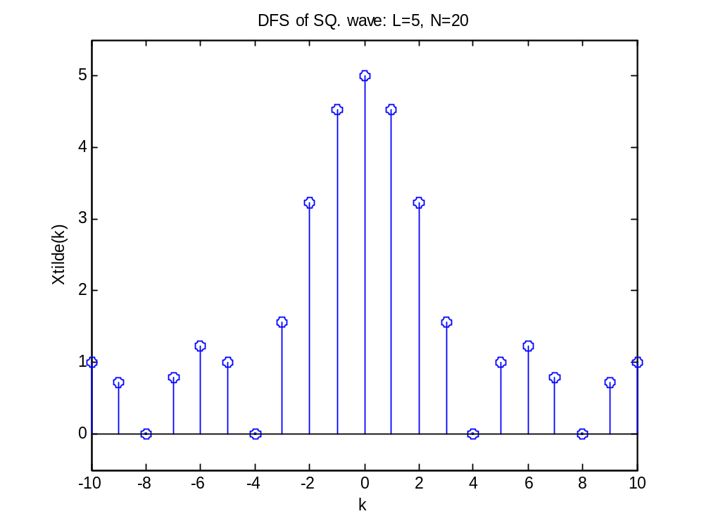

L = 7;
N = 60;
xn = [ones(1,L),zeros(1,N-L)];
Xk = dfs(xn,N);
magXk = abs([Xk(N/2+1:N) Xk(1:N/2+1)]);
k = [-N/2:N/2];

stem(k,magXk);
axis([-N/2,N/2,-0.5,7.5]);
xlabel('k');
ylabel('Xtilde(k)');
title('DFS of SQ. wave: L=7, N=60');
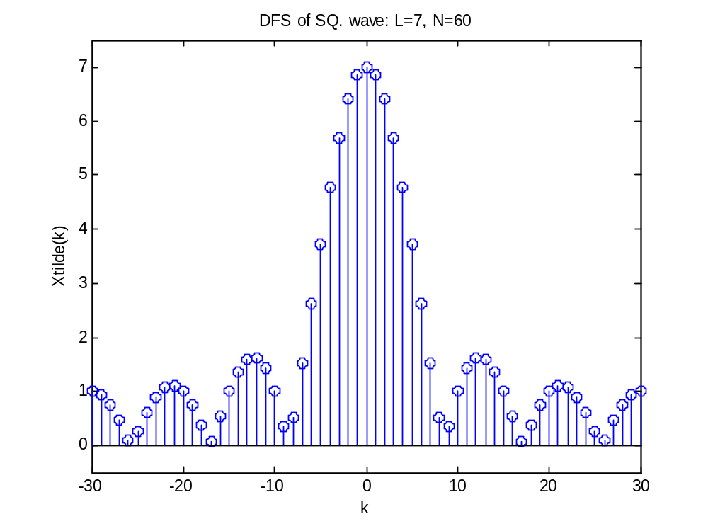

- Plot the DFT (a) magnitude and (b) angle of the following sequence (N=100, ω: 0~π).

x(n)={1, 2, 3, 4, 3, 2, 1}
clear all;
n=-3:3;
x2=[1 2 3 4 3 2 1];
%x3=x2.*n;
n2=length(n);
N=100;
x2=[x2,zeros(1,N-n2)];
X2=DFT(x2,N);
mag=abs(X2);
K=0:N-1,W=pi/N*K;
pha=angle(X2);
subplot(211),plot(W,mag);
subplot(212),plot(W,pha);
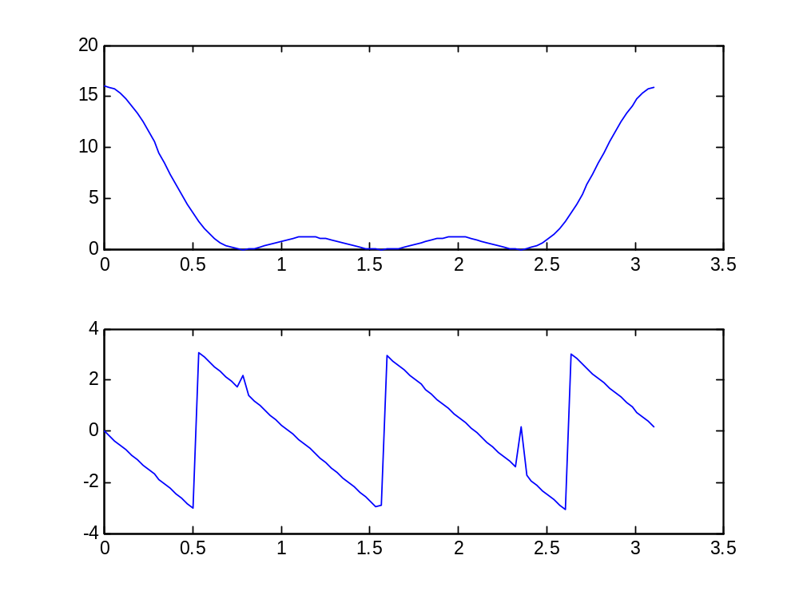

- Let x(n) be a 4-point sequence:
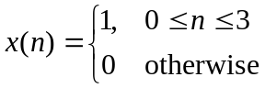
  - Compute the discrete-time Fourier transform (DTFT)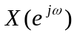and plot its magnitude and phase.

clear all;
w = [0:500]*(pi/250);
x = 1+exp(-j*w)+exp(-j*2*w)+exp(-j*3*w);
mag = abs(x);
pha = angle(x);
subplot(2,1,1);
plot(w/pi,mag);
grid on;
subplot(2,1,2);
plot(w/pi,pha);
grid on;
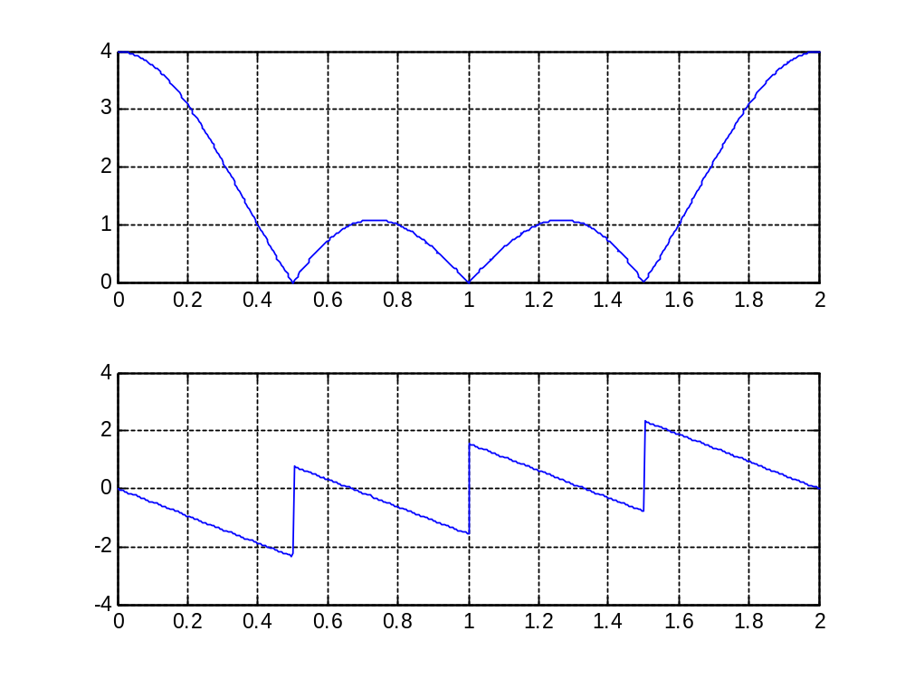

  - Compute and plot the 8-point DFT of x(n).

clear all;
x = [1 1 1 1 zeros(1,4)];
N = 8;
X = dft(x,N);
n = 0:7;
mag = abs(X);
pha = angle(X);
subplot(2,1,1);
stem(n,mag);
subplot(2,1,2);
stem(n,pha);
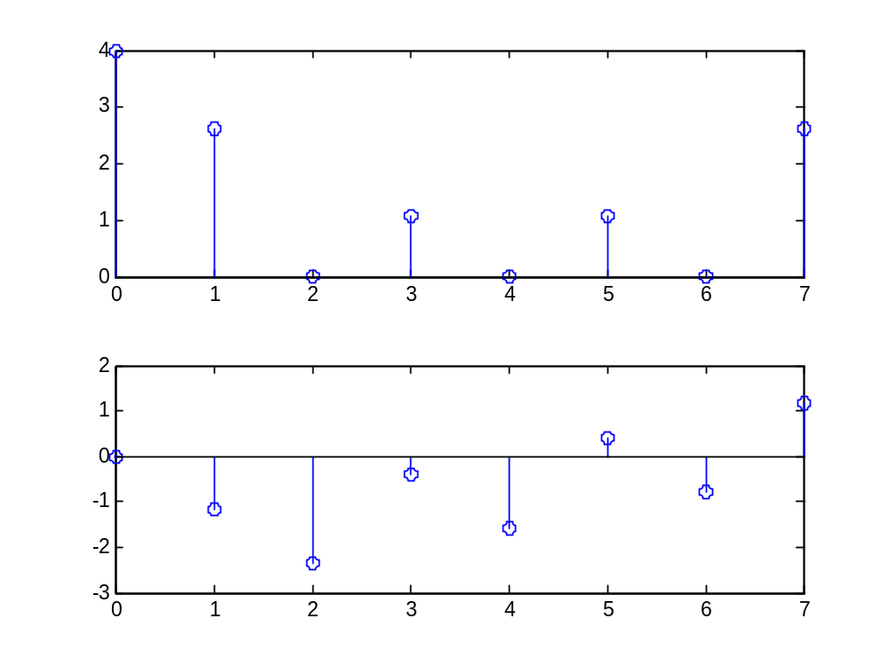

  - Compute and plot the 16-point DFT of x(n).

clear all;
x = [1 1 1 1 zeros(1,12)];
N = 16;
X = dft(x,N);
n = 0:15;
mag = abs(X);
pha = angle(X);
subplot(2,1,1);
stem(n,mag);
subplot(2,1,2);
stem(n,pha);
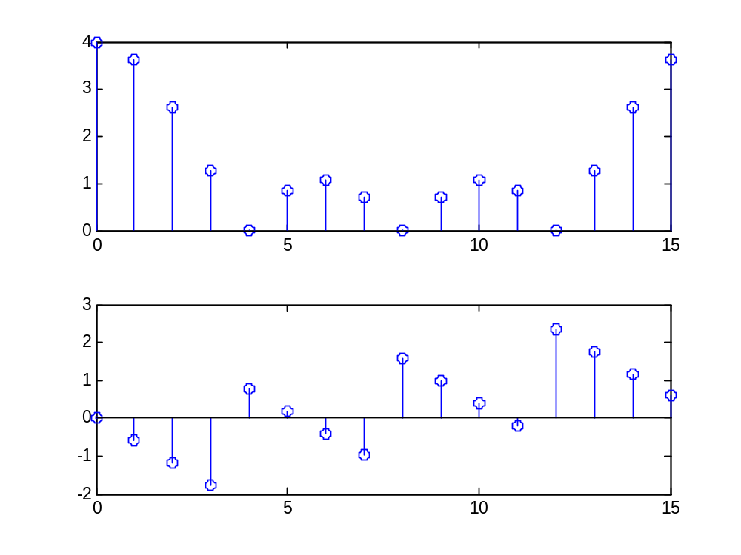

- A system has the following block diagram:

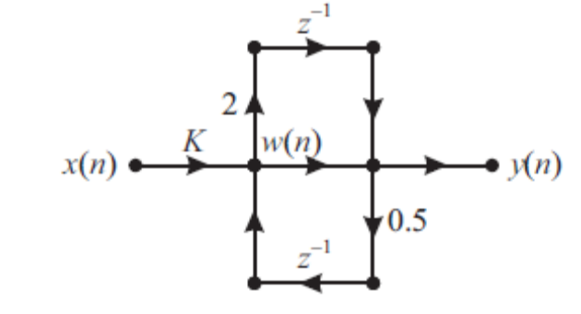
  - Determine the system function H(z)=Y(z)/X(z).
  - Determine the value of K so that H(exp(j0))=1.

- An FIR filter is described by the difference equation
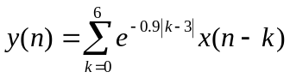

- Find the FIR filter coefficients
- Draw the Direct Form I block diagram structure.
- Draw the Cascade Form block diagram structure.

k = 0:6;
b = exp(-0.9*abs(k-3))
a = 1;
[b0,B,A] = dir2cas(b,a)
